3T at Velofollies with the Latest 2026 Innovations
New storage system for Extrema ITALIA and the new Discus 45|40 LTD wheels showcased in Kortrijk, Belgium, from January 16 to 18 at the first trade event of the year.
[Presezzo, Bergamo, Italy – January 16, 2026, 12:00 CET]
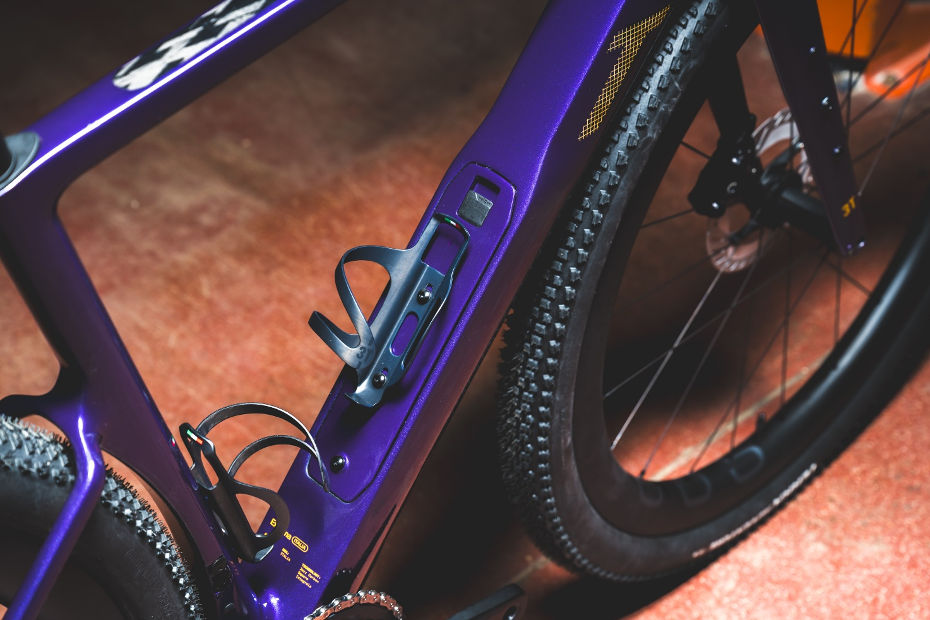
Velofollies is a must-attend event for every cycling enthusiast. Held in Kortrijk, Belgium, the show has reached its 18th edition and represents the first opportunity of the year to present 2026 product innovations to the public and industry professionals.
For 3T- present with its own booth set up in collaboration with the Belgian commercial partner Addict.cc - this is the first opportunity of the new season to showcase its updated range of bicycles and unveil to the public the new Discus 45|40 LTD wheels, along with the new storage system now also available on the Extrema Italia.
The 3T booth at Velofollies is 408-A, and the event will take place at the Kortrijk Xpo from January 16 to 18, 2026.

Evolution of the species, driven by new technologies and community feedback. Internal storage now available on Extrema Italia
3T is not just a bicycle manufacturer; it is a community of people who share a vision, a sensibility, and a passion for cycling. These individuals, both inside and outside the company, are united by a deep passion for the bicycle as a technological object, a form of expression, and a lifestyle.
Based on the requests and positive feedback received from those already using the new storage system on the Racemax² as well as 3T’s intention to extend these technical solutions across its entire product line, the new storage system integrated into the down tube is now also available on the Extrema Italia.
Extrema and Racemax² already share the same proprietary frame construction technologies: Filament Winding and RTM, along with several features and technical solutions designed for adventure and endurance cycling.
Starting today, Extrema Italia also benefits from the internal storage integrated into the down tube: an internal carbon structure volume designed to carry accessories and mini-tools without affecting aerodynamics or bicycle design.
The Extrema Italia down tube features a 60 mm upper cross-section and a 75 mm lower cross-section. This large profile optimizes the airflow coming from the front wheel while keeping the bottles sheltered from the wind. A storage compartment with a dedicated lid is now integrated inside the frame.
The compartment is easily accessible and securely sealed with a Fidlock “mini-hook” lid mechanism. Opening and closing the system is done with a simple click of a small tab.
Inside, a removable neoprene bag, developed in collaboration with MissGrape, ensures stable, rattle-free storage.vibrazioni.
Discus 45|40 LTD Wheels: The Perfect Balance of Performance and Comfort
Designed according to the same philosophy that guides the engineering of 3T bicycles, balancing performance, comfort, and efficiency, the new Discus 45|40 LTD carbon aero wheels are the latest addition to the lineup.
With a 45 mm rim height, 40 mm external width, and 29 mm internal channel, they are optimized for tires between 40 mm and 60 mm. Featuring a truncated NoseTail profile, the rims offer the ideal compromise between aerodynamics and handling, even in crosswind conditions.
The aerodynamic performance of the Discus 45|40 LTD wheels with NoseTail shaping is comparable to that of deeper rims, and pairs perfectly with modern frame designs featuring large down tubes, such as the new 3T Racemax² Italia and Extrema Italia.
Thanks to the large rim and tire volumes, airflow is guided more effectively toward the frame, delivering even greater aerodynamic performance without sacrificing comfort.
With a wide 29 mm internal channel, the Discus 45|40 LTD wheels strike the ideal balance between aerodynamics, lightness, and comfort. Wide channels also allow the tire to interface with the rim in an aerodynamically optimal way, increasing stability, translating into precise steering, greater handling, and improved cornering capability.
The new Discus 45 | 40 LTD wheels weigh 1439 g per wheelset (21 spokes front, 24 rear), over 200 g lighter than the previous version. At the same time, the price drops to EUR 2,098 per wheelset.
MEDIA KIT
High-resolution images are available here.
For more information, visit 3t.bike
SU 3T
At the forefront of carbon frame manufacturing for gravel and road bikes, 3T is a Bergamo-based company headquartered in Presezzo. Utilising cutting-edge processes and patented technologies within its proprietary factory, 3T has established itself as a leading innovator in the cycling industry.
Founded in Turin in 1961 as "Tecno Tubo Torino", the company quickly established itself as a leading producer of bike components. It achieved numerous successes in professional cycling, such as Francesco Moser's hour record in 1984 and victories in the Tour de France by Carlos Sastre in 2008 and the Giro d'Italia by Ryder Hesjedal in 2012.
Since 2016, 3T has been producing frames and complete bikes, with a particular focus on the gravel segment. There, it pioneered the "Exploro" frame, an aero frame designed to tackle off-road terrain. On its 60th anniversary in 2021, 3T launched the first frame produced in its Presezzo factory: the "Racemax Italia."
Today, 3T is committed to bringing the production back home to its headquarters in Bergamo, Italy, as much as possible.

