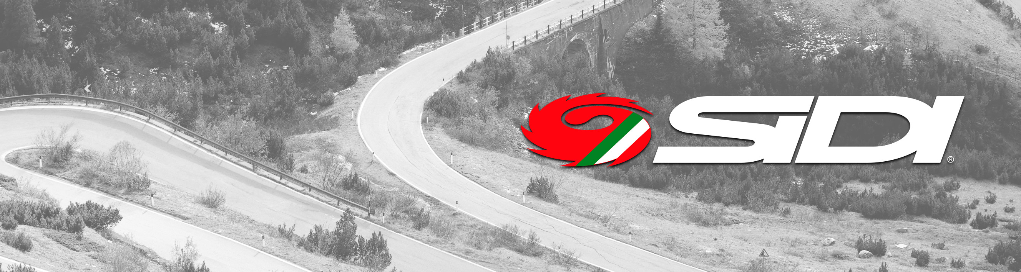

Alba 2, MTB Trace 2, Wire 2 and T-5 air women: the perfect shoes to reach new goals.
8 March, International Women’s Day: Sidi celebrates the women athletes across the world.

Maser, 8 march 2021 - On the International Women’s Day, Sidi pays homage to all the women who pedal every day to reach their personal goals. These shoes have been conceived for demanding athletes, who look for a unique style yet without renouncing performance and comfort. Each of these models is characterized by a special feminine fit modeled on a slender shape with less room on the instep.

Sidi Wire 2 Carbon is a shoe with refined details and cutting-edge technology. Dedicated to the riders who constantly look for a unique combination of lightness and durability, it is characterized by the ultra light Vent Carbon sole that maximizes rigidity while maintaining a proper degree of flexibility required for the best power transfer when pedaling. Several air vents are integrated in the sole, including one in the front, that can be easily regulated with various degrees of opening.
The upper is made with Tech Pro microfiber - a robust, stable, light, water-proof, and anti-mold material.
The shoe is provided with two closures that ensure accurate regulation and high-level comfort. TECNO 3 PUSH SINGLE creates a perfect tightness balance between the internal and the external parts, while the symmetrical closure offers an excellent fit, as it adapts to all kinds of instep and to the slimmest shapes. The same type of mechanism is also included in the upper part and it guarantees the shoe tightness along its entire length, thanks to the SOFT INSTEP CLOSURE SYSTEM - 4, a soft shaped strap that distributes pressure uniformly without needing any spacer.

For a great result at a small price, here are the Sidi Alba 2 shoes: compact, robust, and durable. Made with Politex, a material that ensures resistance against abrasion, they decrease slipping and increase the power transfer thanks to useful details such as an EVA anatomical insert.
The closure, tighter on the front foot, features two velcro straps and the TECNO-3 mechanism that allows you to close the shoes along their entire length, adapting the upper to the foot anatomy and providing the right micro-regulation.
Created with nylon injected with carbon fiber that offers greater rigidity, the Millennium 4 Carbon Composite sole is durable and water-resistant.

Sidi MTB Trace 2 version reflects the features of Alba 2 with a special focus on the off-road requirements. It has the MTB RS17 sole, specifically shaped to ensure great grip and high stability and, at the same time, to facilitate mud dispersion. The toe cap is replaceable and is compatible with the spikes to increase traction on particularly tricky terrains. Last but not least, the central Sidi logo is a useful slip-resistant device, especially for the novice MTB riders.
The Sidi T-5 Air Woman shoes are conceived for women who do not intend to give up on style when riding. They are made with Politex, a multiple layers fabric that provides tear-resistance and long-lasting colour. This shoe features replaceable anatomical inserts made of EVA, a flexible and elastic material placed on the heel so as to decrease slip and to provide greater power transfer while ensuring high comfort. Some internal micro-holes facilitate ventilation. Its Carbon Composite sole is stiff and light, besides being water-resistant.

Media Contacts
Patrizia Falchero | patrizia@atcommunication.it

Further information
www.sidi.com

Facebook | Instagram | Twitter | YouTube

